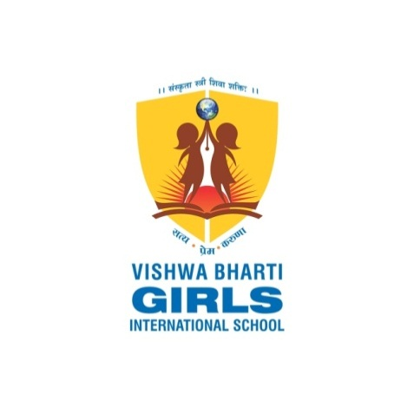 **Managed By Madhav Education Trust**

( Regd.NO.: E / 7744 / Surat Dt. 20-5-2015 )

Vishwabharti Girls Institute of Commerce Management &

Computer Application

Affiliated To Veer Narmad South Gujarat University Surat

At.Po:-Morthana, Simadi-Kosmadi Road, Ta:-Kamrej, Dist:-Surat, Pin-394325. Mo.: 7863864800

***Bachlore of Computer Application***

***(B.C.A)[self-financed]***

***CERTIFICATE***

*This is to certify that the project work carried out at VBGC,Morthana and recorded in this report is the bonafide work of* ***Savalia Juli Manubhai (Exam No. : 7209 )*** *of bachelor of computer Application semester 5, and has been successfully carried out by her as partial fulfillment towards The Degree of B.C.A, under our guidance during the academic year 2024-2025.*

*She was involved in a project for about four Month and was responsible for the design and development of* ***E-Commerce Website*** *at college as in-house Project.*

*Miss Punam Patel*

(Guide Name)

(Internal Examinar)

**____________________________**

(External Examinar)

*Mr. Vinodbhai Gajera*

*Principal Vishwabharti Girls Institute of Commerce*

*Management &Computer Application,Morthana*

Email :[vishwabhartigirlscolleges@gmail.com](mailto:vishwabhartigirlscolleges@gmail.com)